North Side High School Alumni Association
6th annual Golf Outing
At Riverbend Golf Course
July 24, 2021
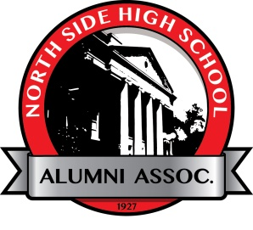
Hole Sponsorship
The proceeds from these sponsorships will be used for Grants. The cost of hole sponsorship is $50 which includes the sign on the hole of your choosing (if available) and a thank you mention in our newsletter, Totem Tales, and recognition on our web page and social media. Deadline for sponsorship is July 14th.
If you would like to sponsor a hole, please fill out the form below and send a check to
North Side High School Alumni Association
475 E State Blvd.
Fort Wayne, In 46805

Name of Organization on Sign_____________________________________________________________
Any other information for the Sign_________________________________________________________
Logo to use (Attach if possible)_______________________________
Hole Choice (1-18)_____________________________________

