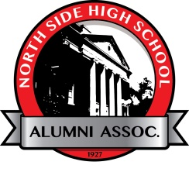

The North Side High School Alumni Association Mission

The North Side High School Alumni Association
exists to conduct activities exclusively
for charitable and educational purposes
related to the betterment and support of NSHS.

_ _ _ _ _ _ _ _ _ _ _ _ _ _ _ _ _ _ _ _ _ _ _ _ _ _ _ _ _ _ _ _ _ _ _ _ _ _ _ _ _ _ _ _ _ _ _ _ _ _ _ _

Reservation for the NSHS Alumni Association’s Seniors’ Reunion Luncheon May 18, 2018
RSVP by May 11, 2018 in the enclosed self-addressed envelope.

Will you be attending: Yes____ # Attending_________@$25.00 each
Choose Meat Selection: Beef Tips _______ or Chicken Picatta _______

No _____ I cannot attend but wish to donate to Grants ______(amt) Scholarships _______ (amt)
Name ____________________________ Maiden Name _______________________________
Year Graduated ________ Guest Name _________________________NS Grad?___Year_____
Address __________________________________City_________________ State___________
Home Phone ________________ Cell Phone ________________ Email ___________________

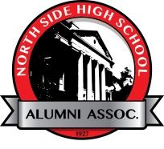

The North Side High School Alumni Office
475 East State Blvd., Fort Wayne, IN 46805
Phone: 260-471-7197 Email: nshsaa@gmail.com Website: www.nsalumni.org

Watch for promotion of future NSHSAA Events:

Distinguished Alumni Breakfast – June 16, 2018

NSHSAA Golf Outing – July 28, 2018

Sports Hall of Fame Breakfast – August 25, 2018

